Use Read Aloud (text-to-speech) Desktop

What does it do?
Reads the text on the page out loud and highlights each word as it is read.

How do I use it?

If you are using a desktop version of Word, you can go to the Review tab and select Read Aloud.

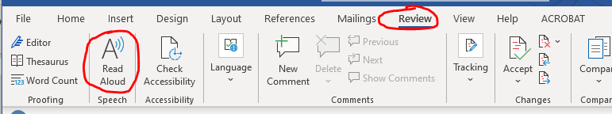

Word will automatically start reading from wherever your mouse cursor is placed. You will also see controls pop up on the top right hand corner of your document to allow you to pause and skip forwards and backwards.

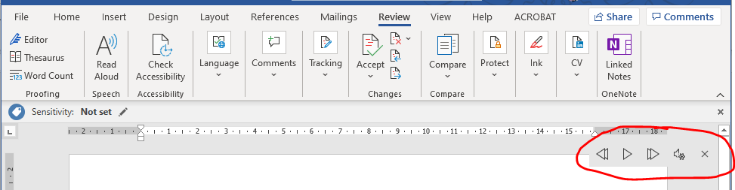

Select the settings icon to change the speed or the voice of the reader:

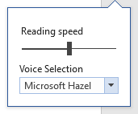
Each word will be highlighted in grey as it is read so that you can follow along with the reader.

Use Immersive Reader

What does it do?
Creates a distraction free and customisable reading frame. Not all versions of Microsoft Word will have the Immersive Reader function. If you do not have this option in your desktop version you can still use this functionality by opening your Word document using the online version of Word provided by the University.

How can it help?
Reduce distractions when reading and customise the set up to make reading easier. It also works with Read Aloud.

How do I use it?
Go to the View tab and select Immersive Reader.

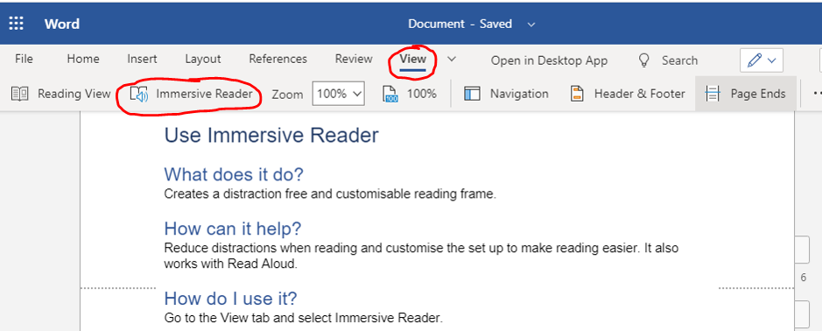

Then you will see your document in a less cluttered and ‘reading friendly’ view. The first time you use Immersive Reader you will see some tips on how to use the functions.

This will show you where the audio (text-to-speech) settings are:
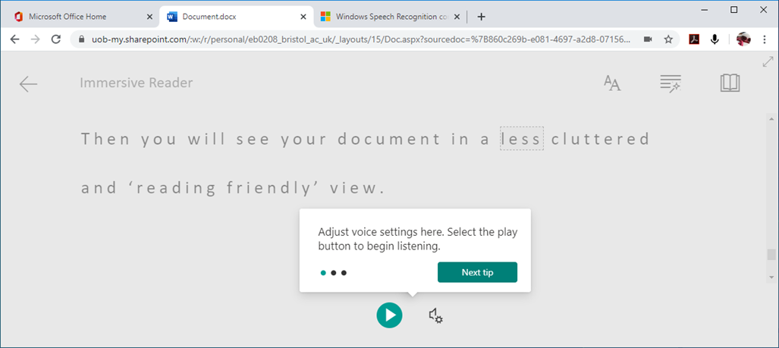

Where to adjust the size, spacing and colours:

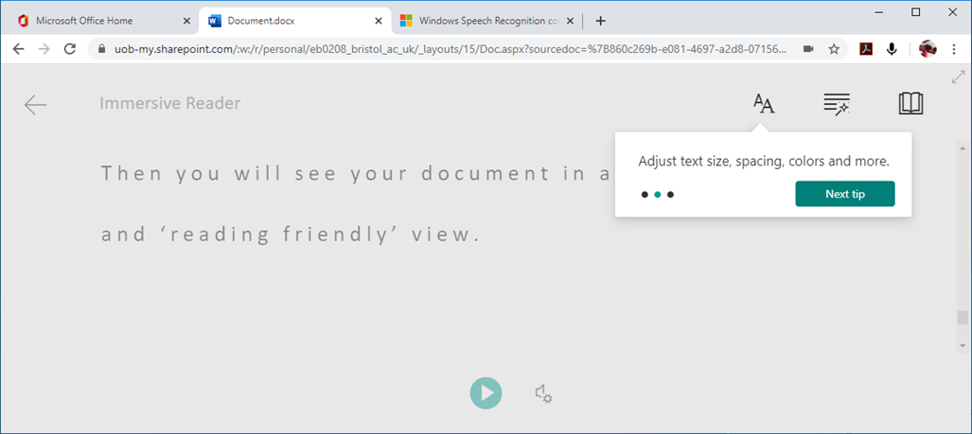

And how to further improve your focus on the text you are reading:

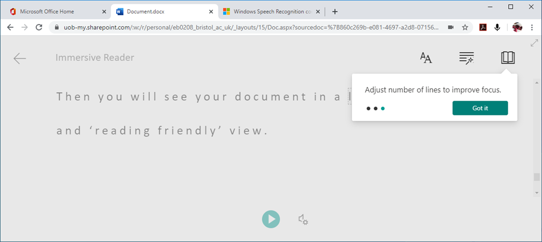

You can change the background colour to reduce eye strain:

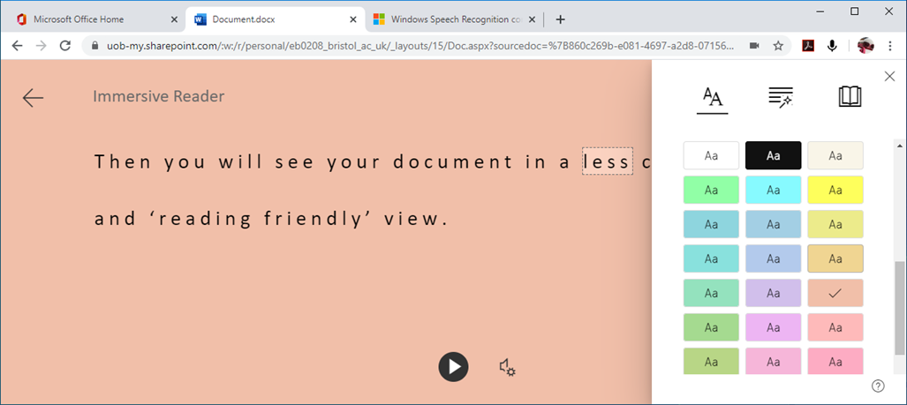

And use a function that is similar to a ‘reading ruler’ that will help you focus line by line as you read:

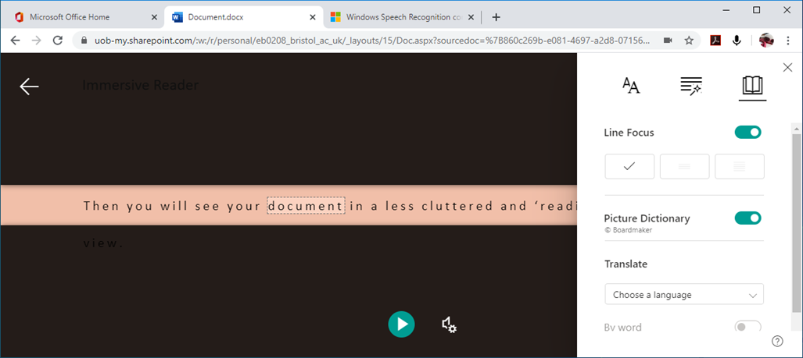

You may notice that images from the original Word document have been removed. This is to reduce visual distractions. The images will still be visible in the main document when you exit the Immersive Reader screen.

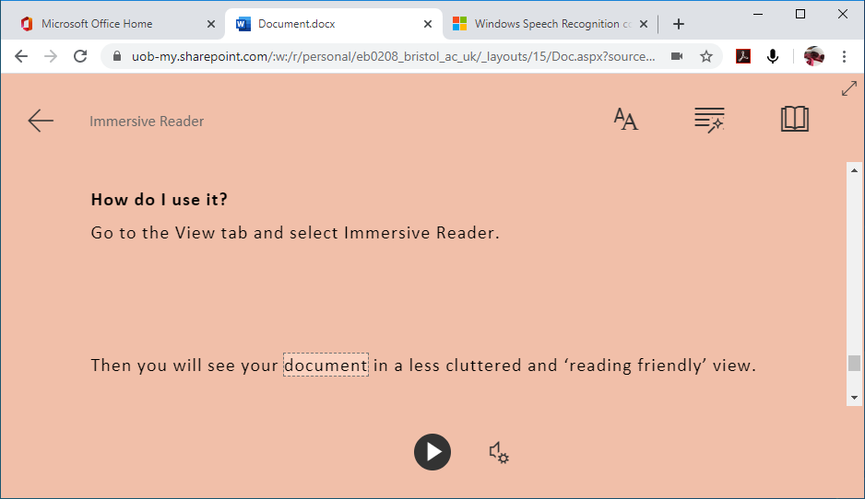

Use the Play icon at the bottom of the screen to begin audio. Immersive Reader will then read the text aloud. To the right of the Play icon are the settings, where you can choose the playback speed and select your preference voice. Each word will be highlighted as it is read, so that you can follow along.

When you are ready to return to your Word document, select the Exit arrow on the top left.

